STEREO HEADSET
BLUETOOTH
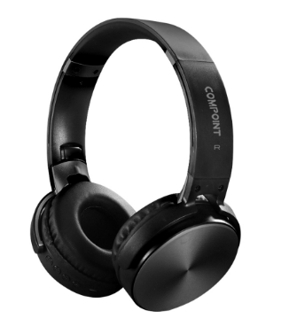
CP-HBT35

Descrption:
Looking for a quality, surround-sound Bluetooth(tm) HD headphone system in a folding design together with hands-free phone communications?

The exciting Compoint(tm) CP-HBT35 is your ideal audio partner for intense gaming, relaxing to your favorite songs or, if needed, using complete hands-free operation via its integrated microphone.

With its built-in, powerful 40mm driver units offering deep bass and sharp treble means you'll enjoy HD sound via Bluetooth(tm) via its long lasting rechargeable battery system. Need to connect to your non Bluetooth(tm) device? Integral 3.5mm phono jack means you can do just that.

Built-in TF-card reader means you can play songs from the card itself via its on-board controls and with its comfortable over head, folding design together with ambient noise suppression thanks to its padded ear profiles means you can take these cans' anywhere.

FEATURES
  - Bluetooth(tm) Version 5.0 - Up to 10m range
  - Bluetooth(tm) Profiles - A2DP1.2, AVRCP 1.4, HFP1.6
  - Driver Units - 40mm Dynamode Drivers for clarity
  - Impedance - 32 Ohms +/- 15%
  - Frequency Range - 8Hz to 24Khz Sensitivity 121 +/- 3dB
  - On-board control buttons with MP3 playback
  - Stylish and comfortable over-head design
  - Battery Life - Up to 14 Hours (depending on usage)

.SPECIFICATIONS:
  - Bluetooth(tm):Bluetooth(tm) Version 5.0
  - Profile:A2DP1.2 AVRCP
  - 1. 4HFP1.6 HSP1.2.
  - RF Range:10M
  - Dimension Drive:Φ40MM
  - Impedance:32Ω±15%
  - Frequency Range:20~20KHz
  - S/N Rate:>80dB
  - Distortion:<1%
  - Time:14H

